# Run flows on a schedule

1. [Create a recurring flow](https://learn.microsoft.com/en-us/power-automate/run-scheduled-tasks?tabs=classic-designer#create-a-recurring-flow)
2. [Configure advanced options](https://learn.microsoft.com/en-us/power-automate/run-scheduled-tasks?tabs=classic-designer#configure-advanced-options)

Create a cloud flow that performs one or more tasks (such as sending a report in email).

* Once a day, an hour, or a minute.
* On a date that you specify.
* After a number days, hours, or minutes that you specify.

**Create a recurring flow**

1. Sign in to [Power Automate](https://make.powerautomate.com/).
2. Select **My flows** > **New flow** > **Scheduled cloud flow**.
3. In the fields next to **Starting**, specify the date and time when your flow should start.
4. In the fields next to **Repeat every**, specify the flow's recurrence.
5. Select **Create**.

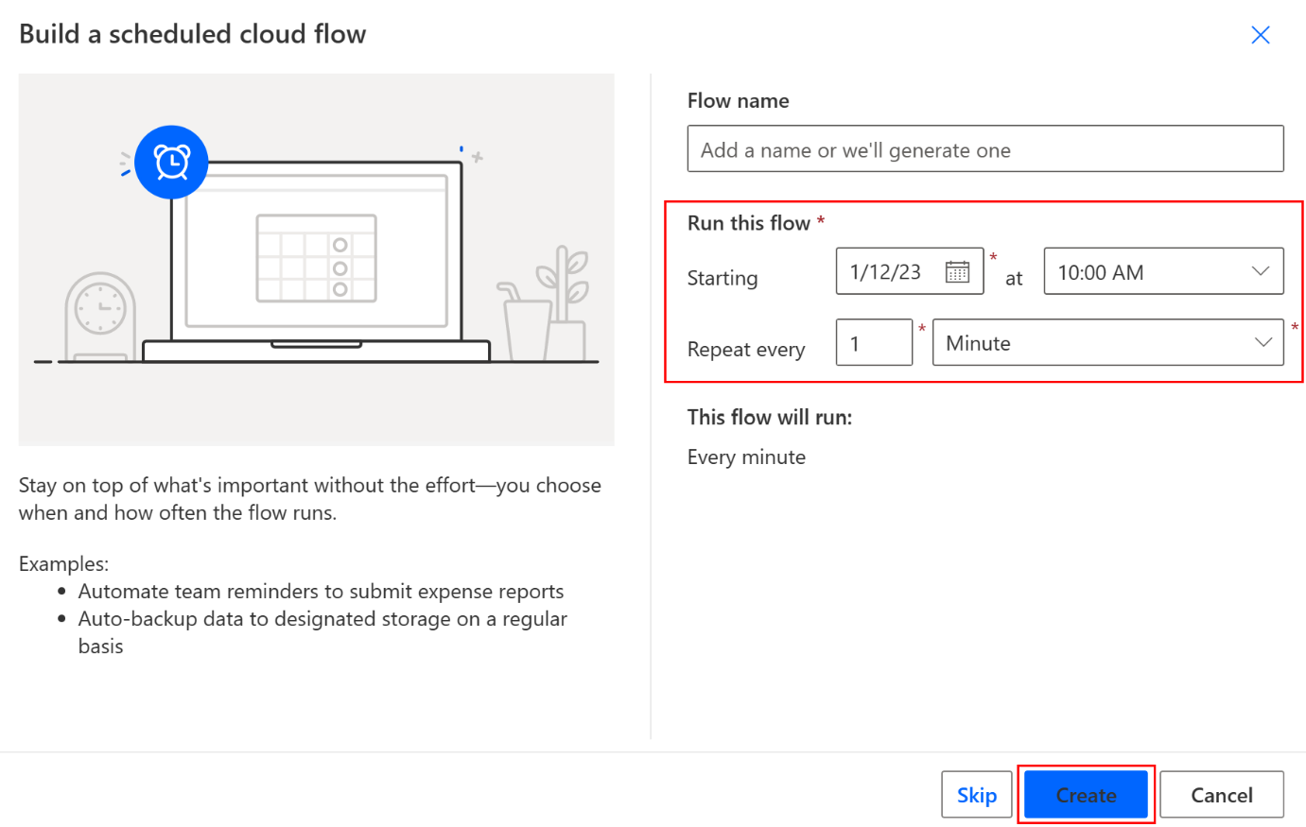

**Note**

Power Automate uses either the classic cloud flows designer or the cloud flows designer with Copilot. To identify which designer you’re using, go to the **Note** section in [**Understand the cloud flows designer with copilot capabilities**](https://learn.microsoft.com/en-us/power-automate/flows-designer).

**Configure advanced options**

* [Classic designer](https://learn.microsoft.com/en-us/power-automate/run-scheduled-tasks?tabs=classic-designer#tabpanel_1_classic-designer)
* [Edit with Copilot](https://learn.microsoft.com/en-us/power-automate/run-scheduled-tasks?tabs=classic-designer#tabpanel_1_edit-with-copilot)

1. Follow the steps in the previous section.
2. Select **Recurrence** > **Show advanced options**. When you select **Show advanced options**, the dropdown name changes to **Hide advanced options**.

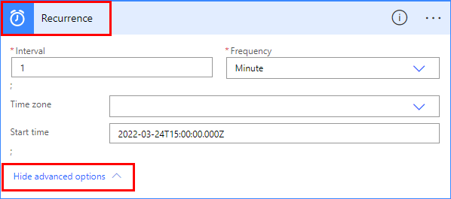

1. In the **Time zone** field, select a time zone from the dropdown list to specify whether the **Start time** reflects a local time zone, Coordinated Universal Time (UTC), or other time zone.
2. In the **Start time** field, enter a start time in this format: YYYY-MM-DDTHH:MM:SSZ
3. If you specified **Day** under **Frequency**, select the time of day when the flow should run in the **At these hours** and **At these minutes** dropdown lists.
4. If you specified **Week** under **Frequency**, do the following.
   * In the **On these days** and **At these hours** dropdown lists, select the day or days of the week on which the flow should run and the time or times of day when the flow should run.
   * In the **At these minutes** field, enter the minute values (from 0 to 59) separated by a comma.

For example, configure the options as shown to start a cloud flow no sooner than 3:00 PM (Pacific time) on Thursday, March 24, 2022, and run it every two weeks on Tuesdays at 5:30 PM (Pacific time).

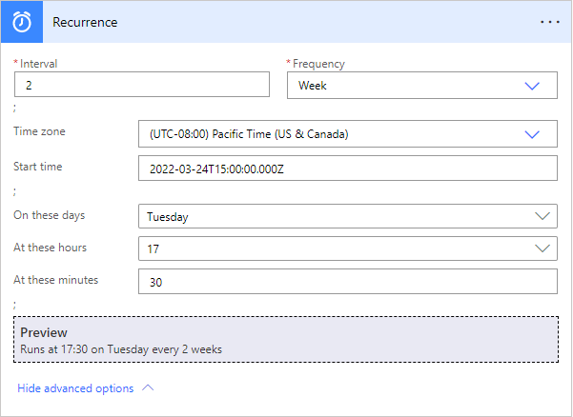

**Note**

If you run a flow on the month frequency, the flow runs on the same date each month.

1. Add the action or actions that you want the flow to take, as described in [Create a cloud flow from scratch](https://learn.microsoft.com/en-us/power-automate/get-started-logic-flow).